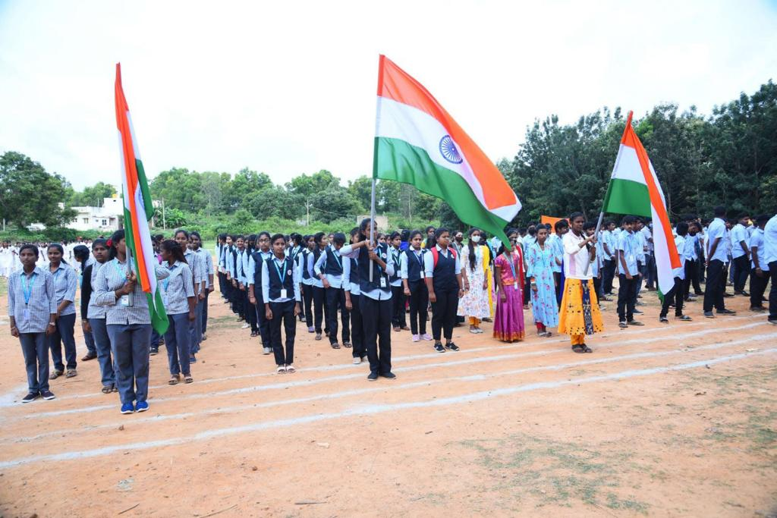75th INDEPENDENCE DAY: n 15-08-2023

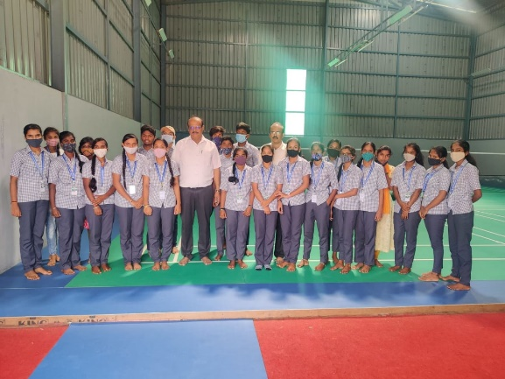

Inauguration of Badminton Court

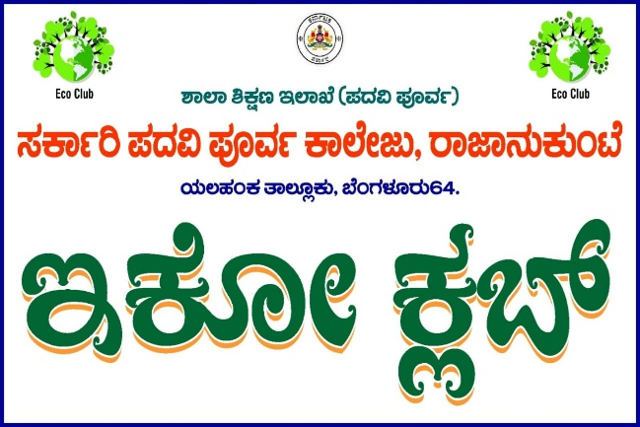

Inaugration of Eco Club

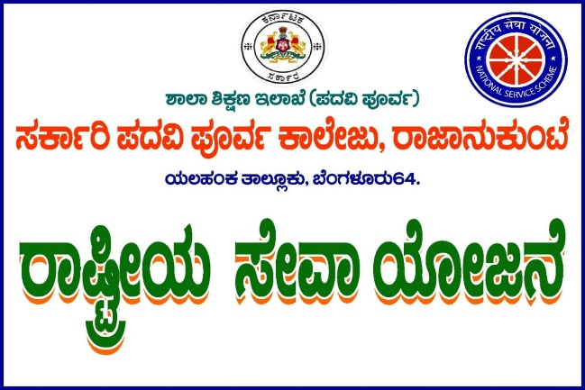Inaugration of Rastriya Seva Yojane

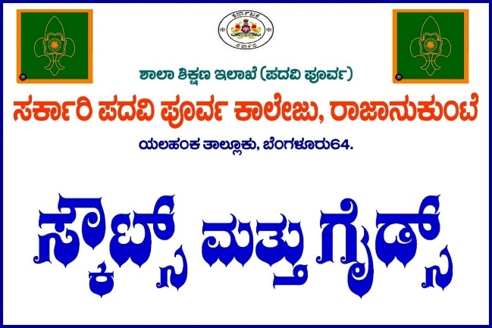 Inaugration of Scouts and Guides

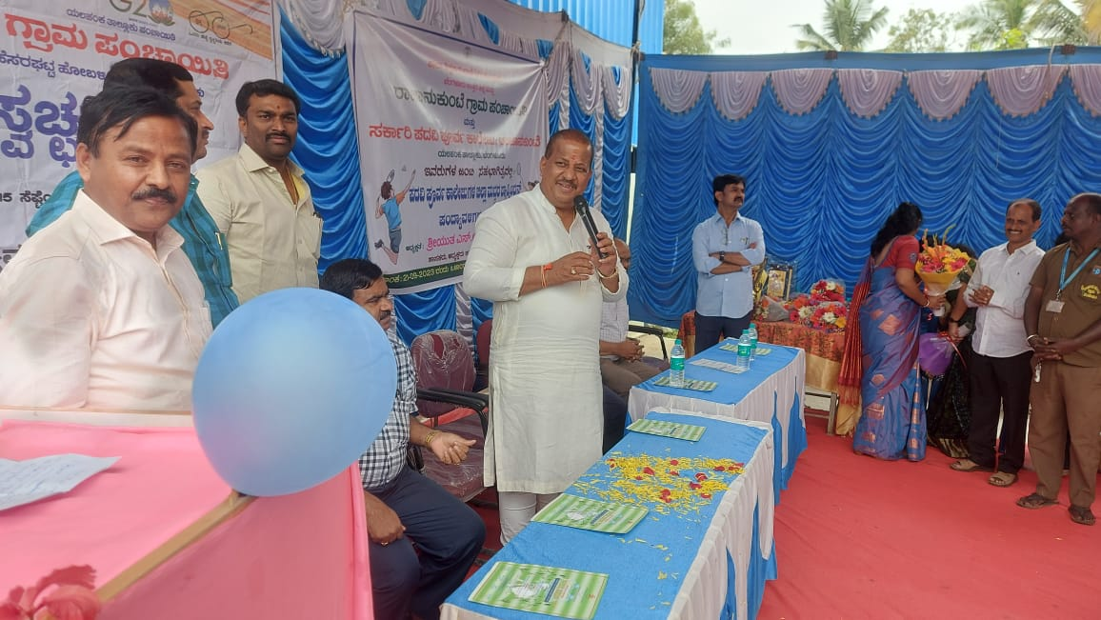 Event to create awareness about environmental health by MLA of yellanka, S. R . Vishwanath

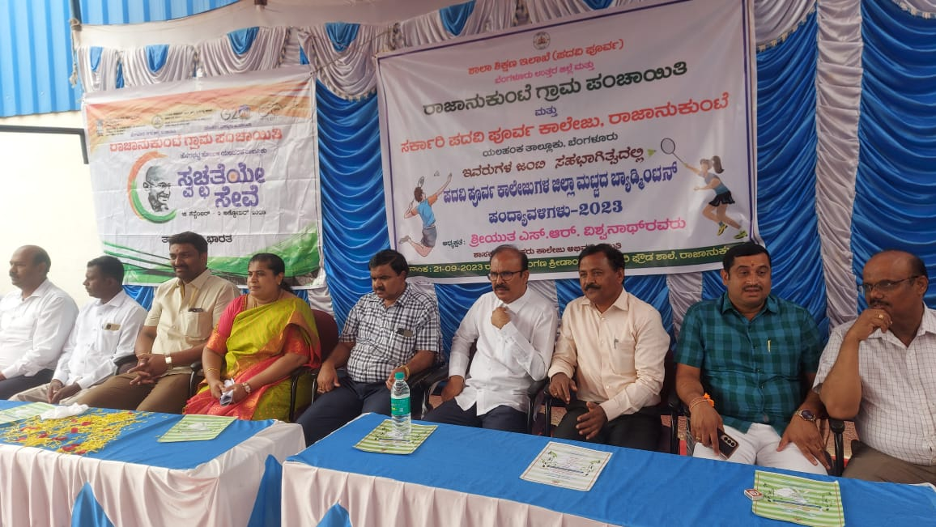 opening ceremony of batmintion Court

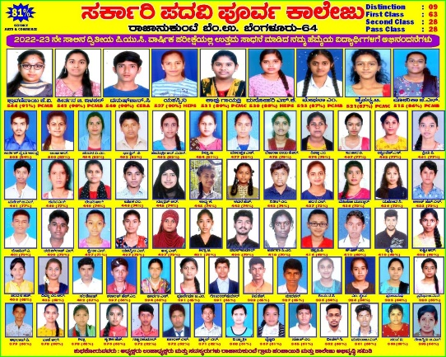 Recognition of Academic excellence of meritorious Students of College

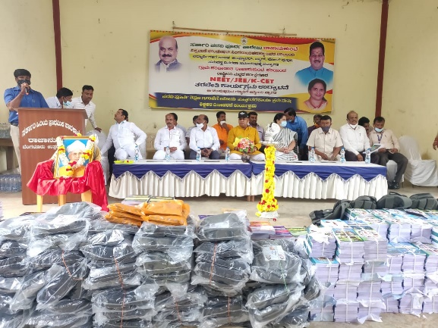 Distribution of Bags and Books to students from the Institution

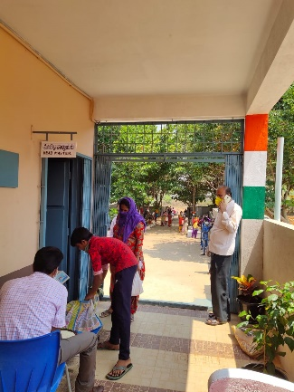 Distribution of necessary aid during Covid

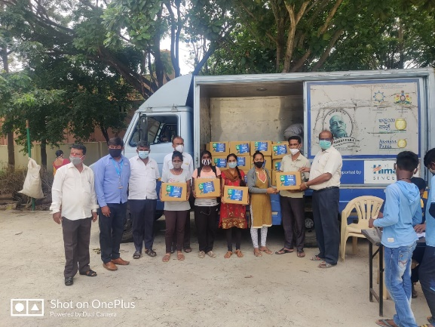 Distribution of necessary aid to Students from College during Covid

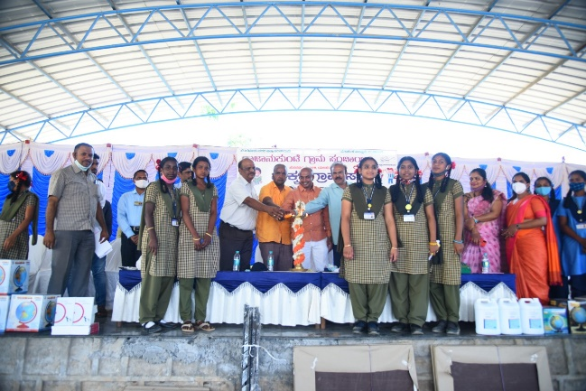

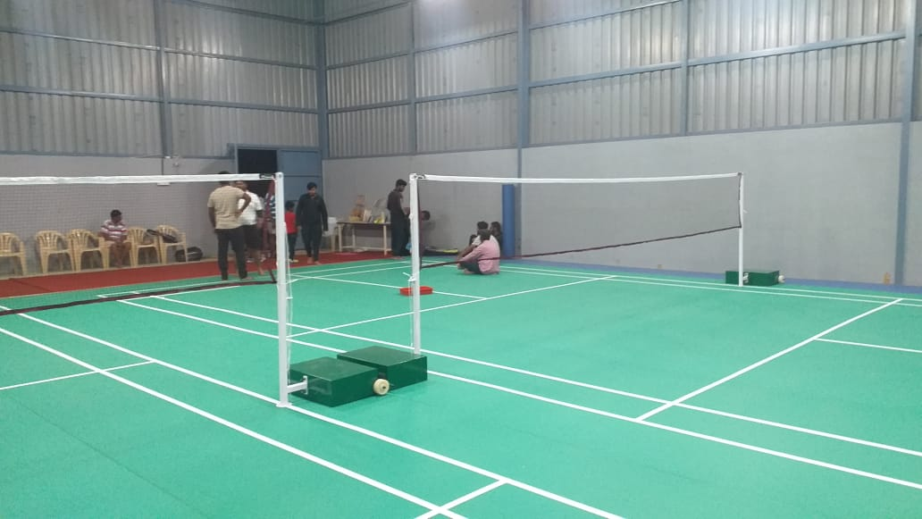 Photo of newly inaugurated Batmintion Court

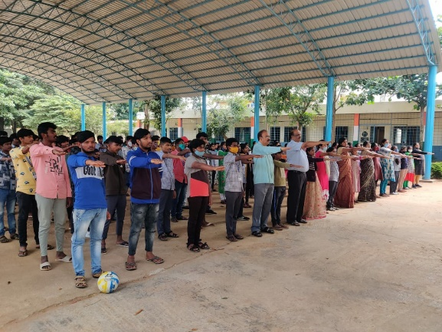 taking Oath about upholding Constitution

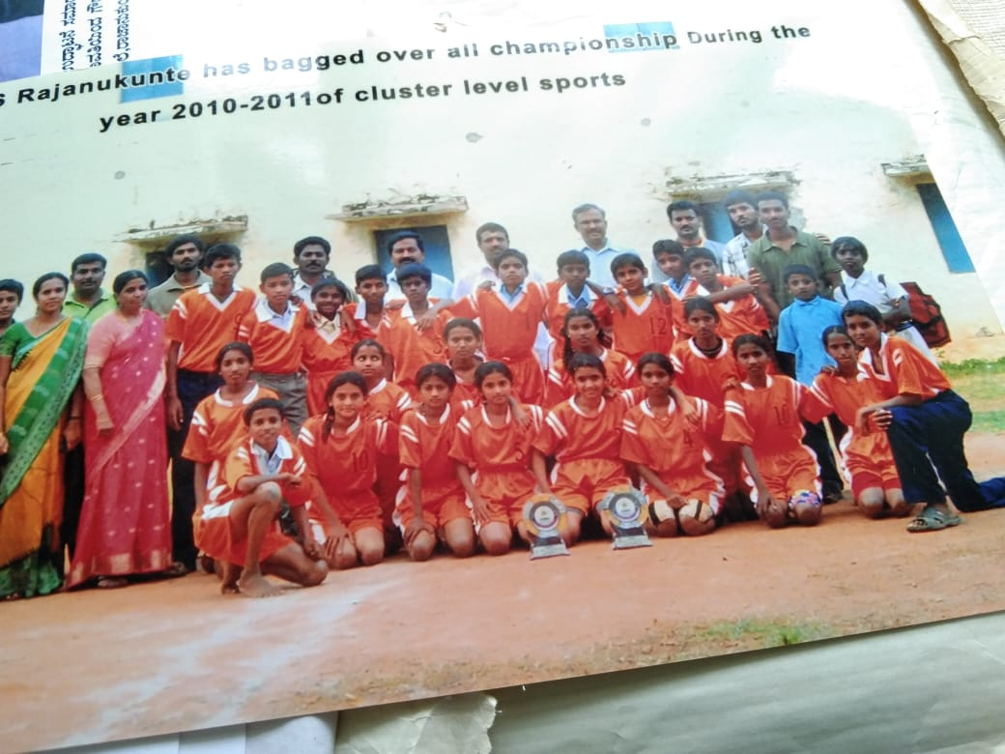 sports team of high school participating in cluster level sports

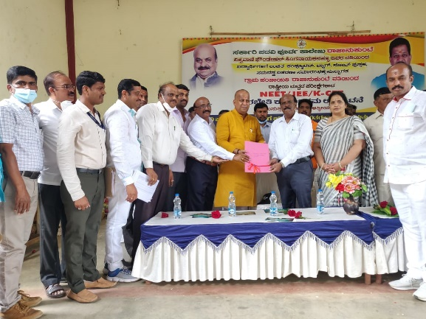 Opening ceremony to provide NEET JEE coaching in college

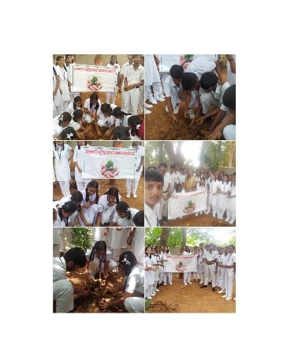 Program On Environmental day awareness

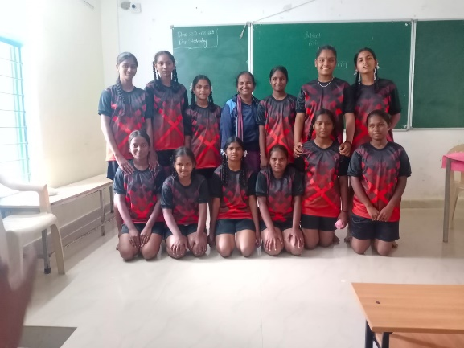 Participating in High School Level Sports

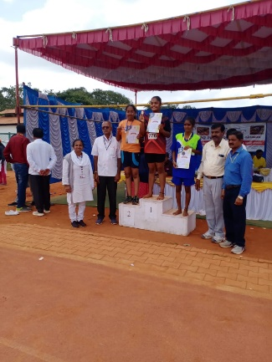 Prize Distribution to Winners of High School level Sports

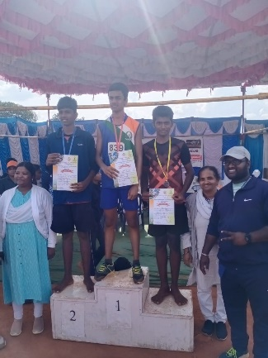 Prize Distribution to Winners of High School level Sports (no 2)

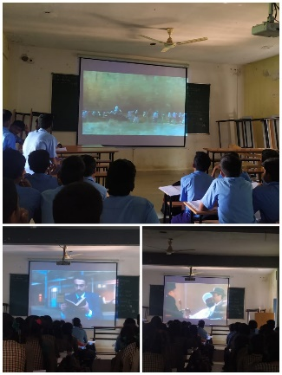 classroom with Smart Screens and Projector Facilities

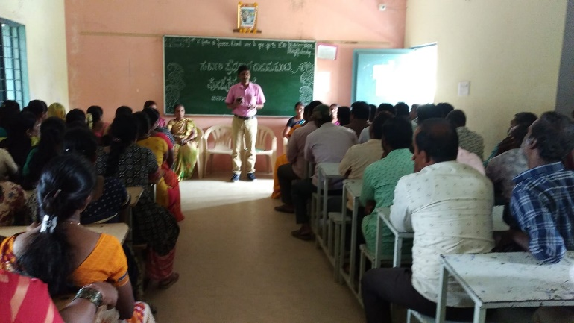 Parents – teachers meeting to discuss academic well being of students

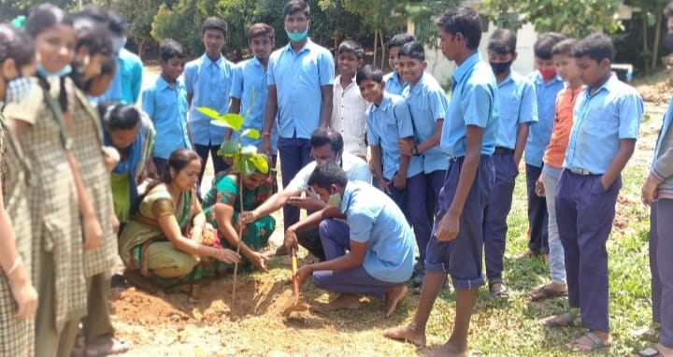 plantation to create environmental awareness among students

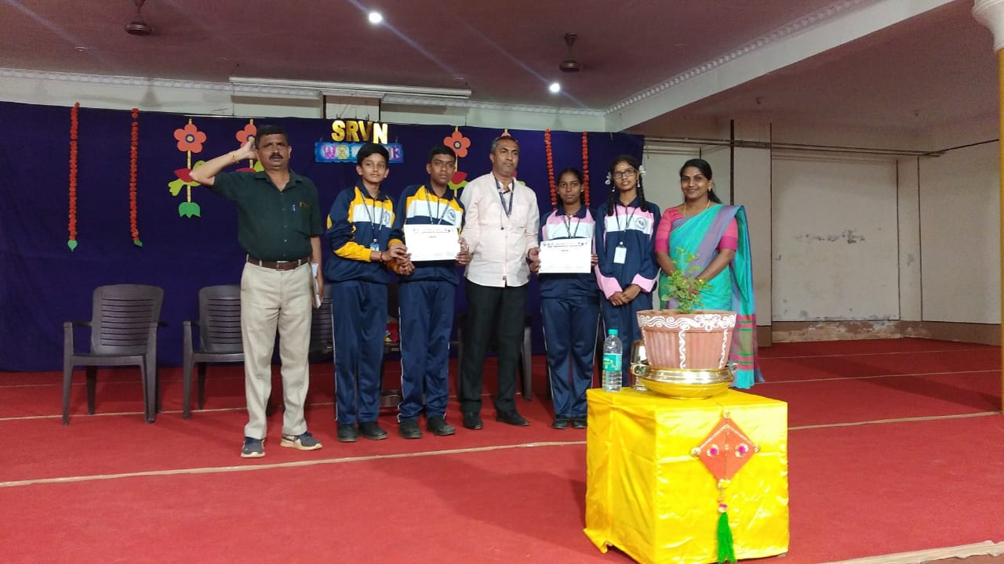

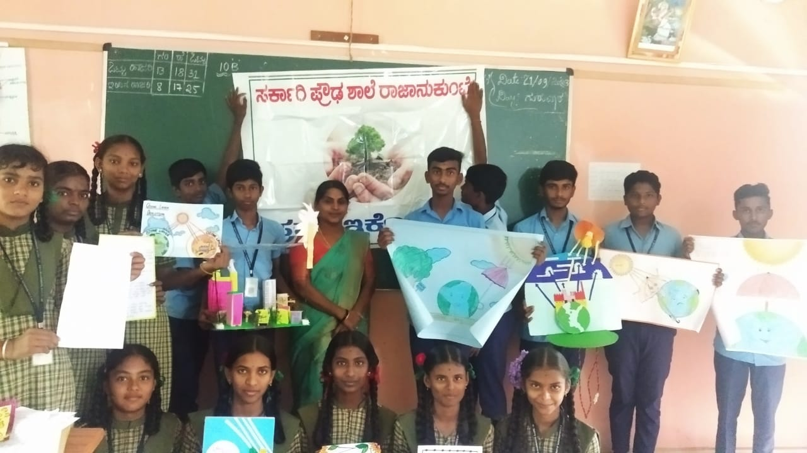 Project work by students regarding environment

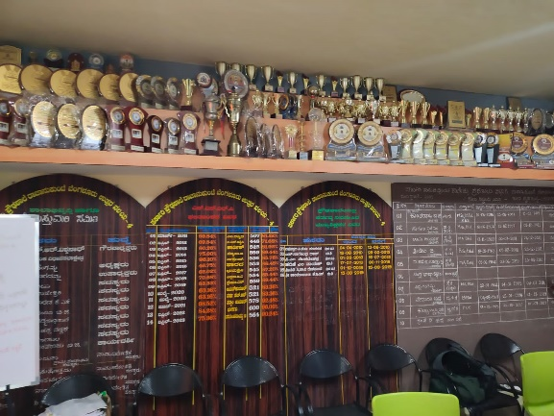 Complete Prize gallery awarded to govt high school

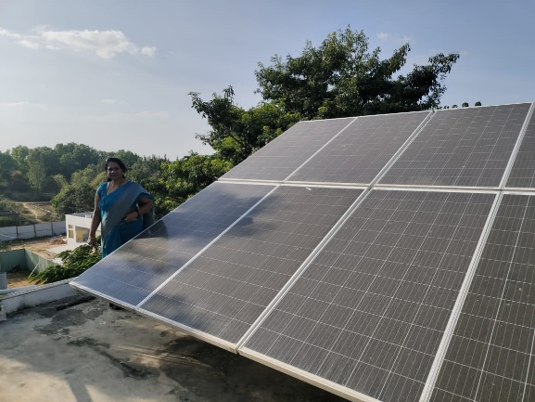 Installation of solar panels to generate clean energy for institutions

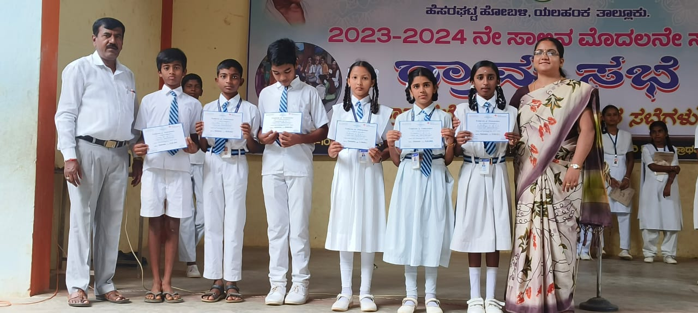 Awarding certificates for well performing Students in primary School

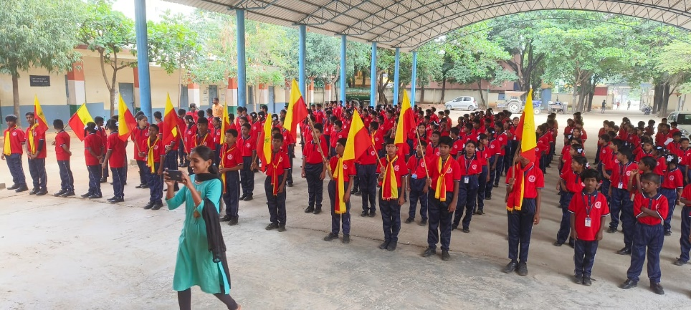 celebration of Kannada Rajyotsava

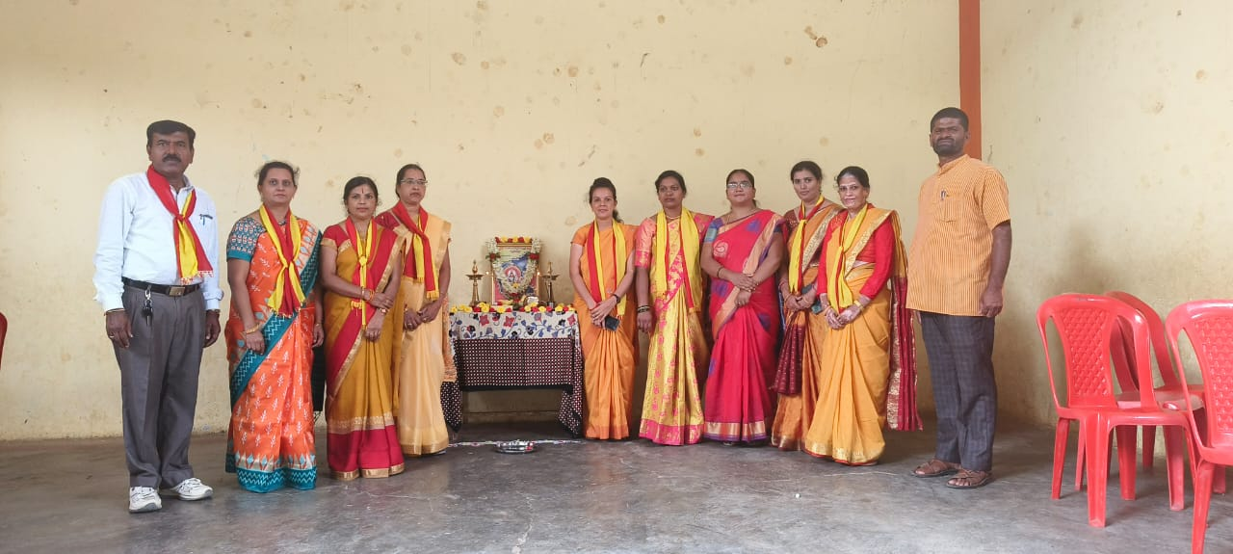 opening Ceremony to commence Kannada Rajyotsava Celebration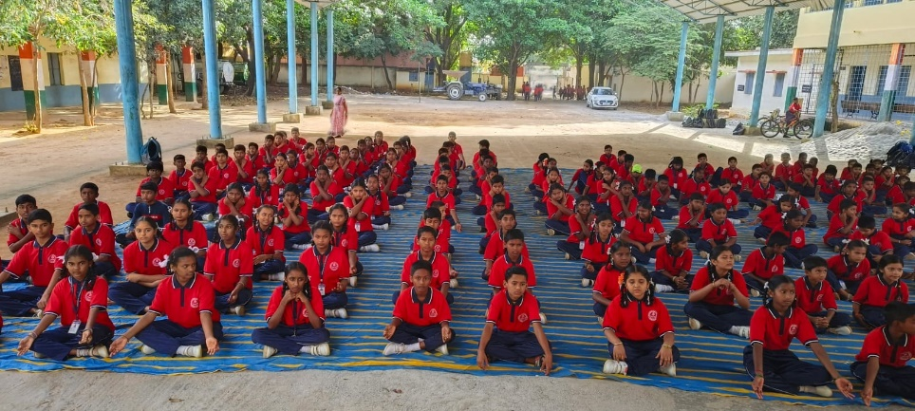 Physical education to Primary School students

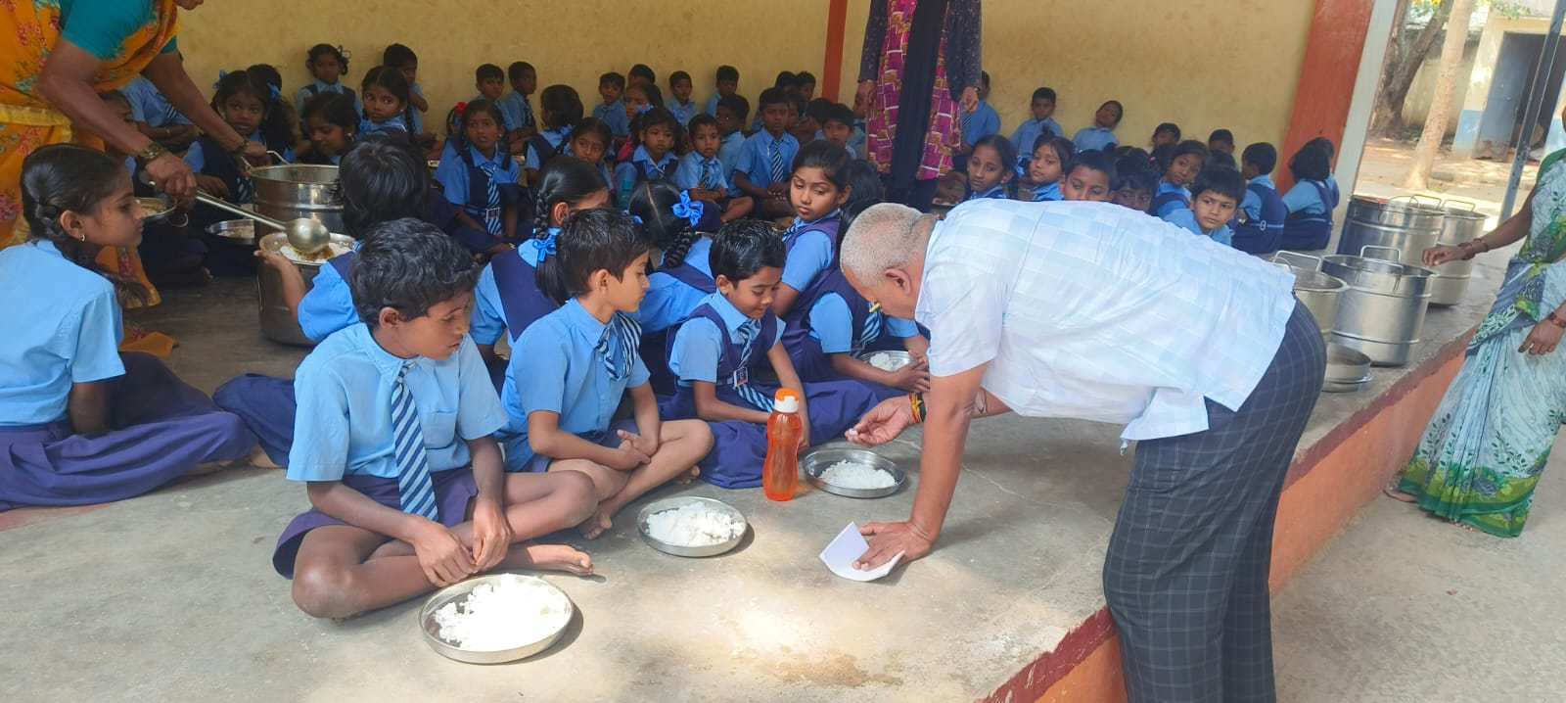 providing nutrient food facilities to primary school students

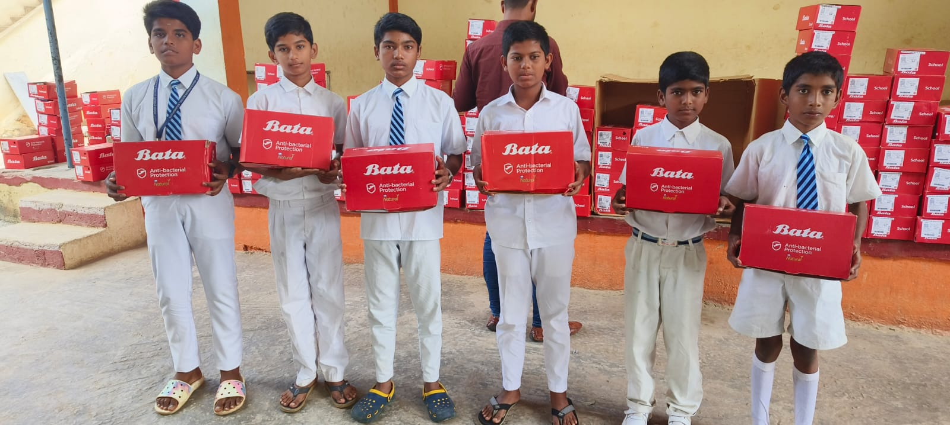

Distribution of Shoes to Primary school students

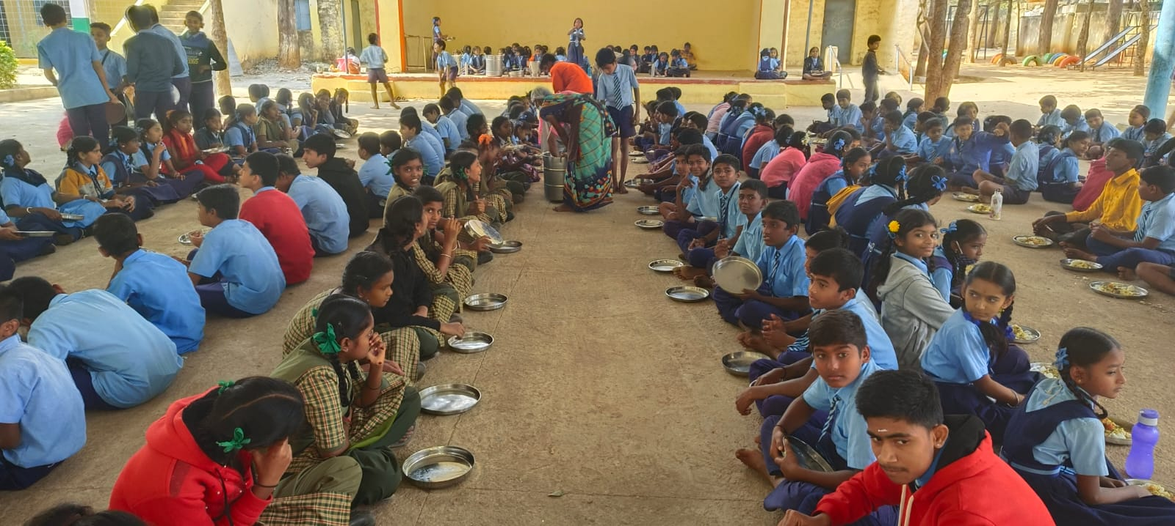 Providing Nutrient Food Facilities to Primary High school Students

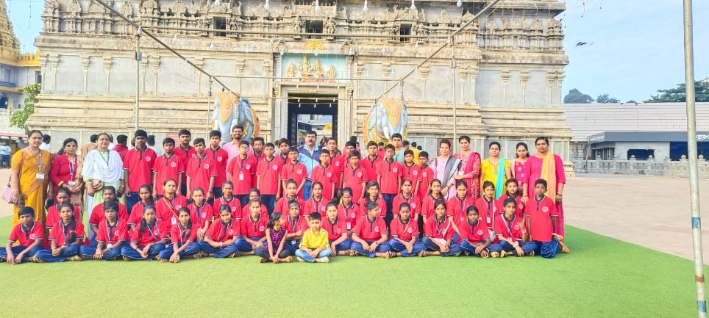 Photos of School trip

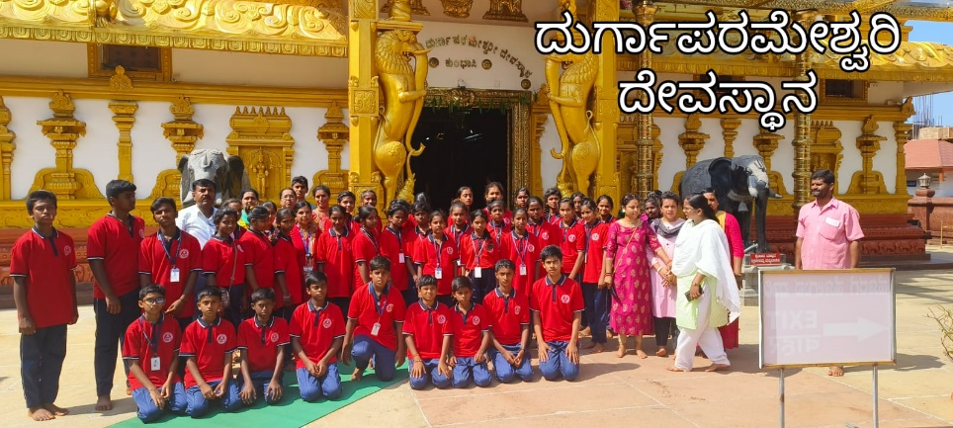 Photo of school trip

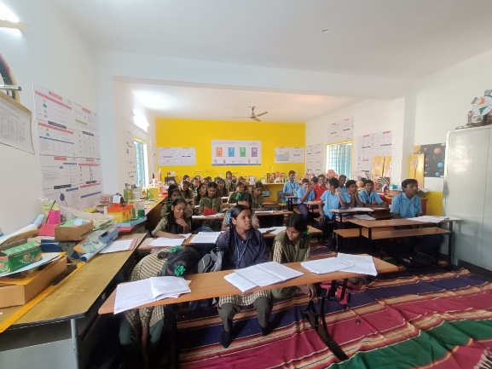 photo taken during science classes

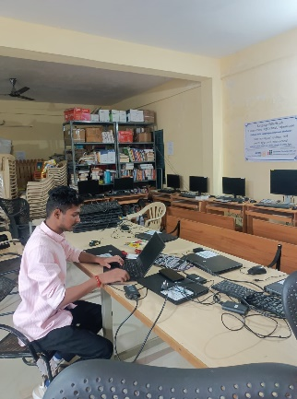 well equipped Lab Facilities for High school students

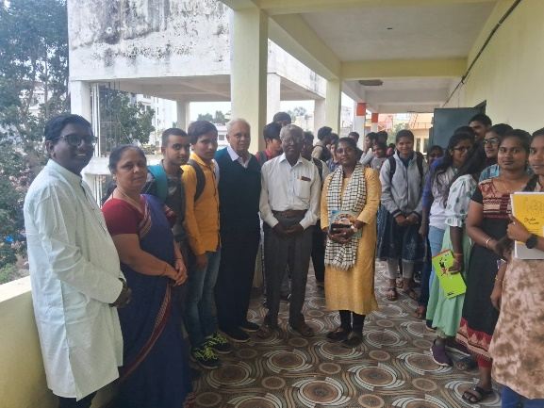Dr,. S Anantaraj, Student Scientist Interaction

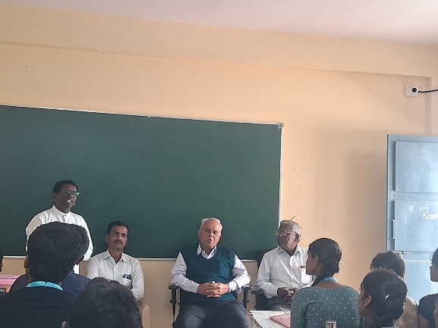 Dr,. S Anantaraj, Student – scientist Interaction

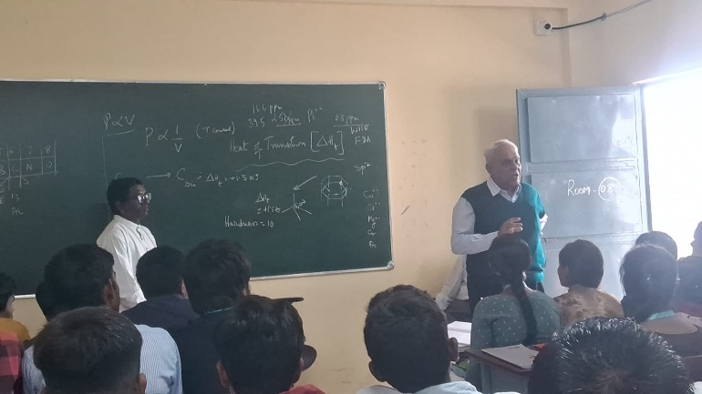 Dr,. S Anantaraj, Student Scientist Interaction